1.
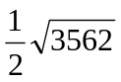

2.
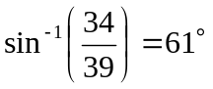

3.
(i) 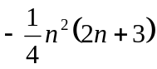
(ii) 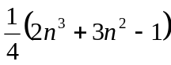

4.
(i) Prove by mathematical induction.
(ii) Prove by mathematical induction.

5.
(i) 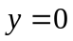 , 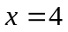 , 
(ii) Local maximum point : 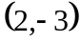 , local minimum point : 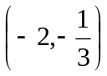

6.
(i) 